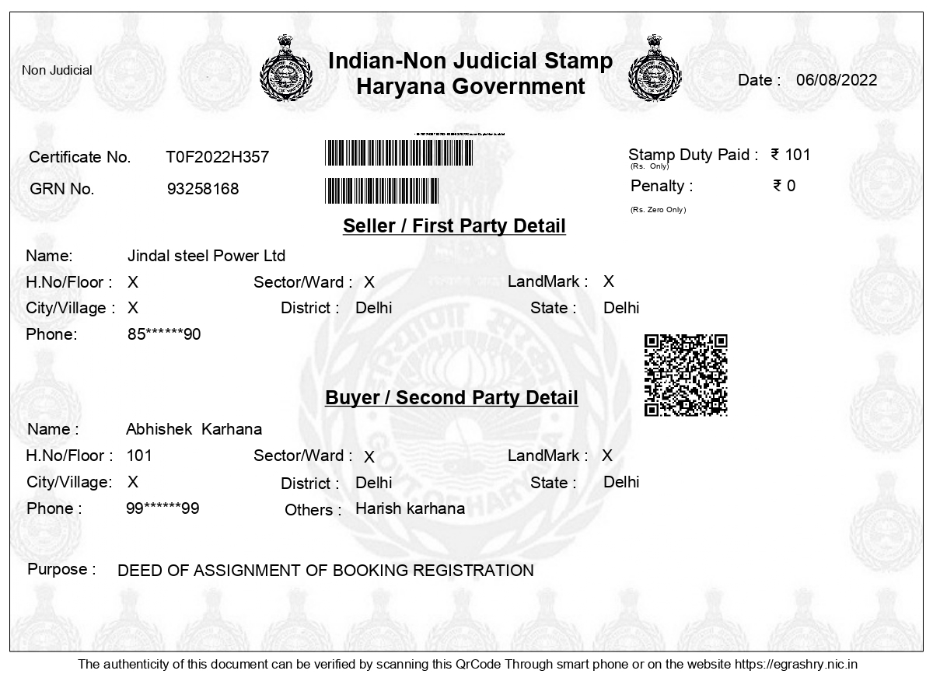
DEED OF ASSIGNMENT OF BOOKING / REGISTRATION

This “Deed of Assignment” is made at ………… on this …………. day of December 2021

BETWEEN

_____________________________________________________________________________________________________________ (hereinafter referred as the “TRANSFEROR/ ASSIGNOR”, which expression shall, unless repugnant to the context, include his/her/their successors, heirs, attorneys and permitted assigns) of the FIRST PART;
AND

_________________________________________________________________________________________________________________________________________________________________________ (hereinafter referred as the “TRANSFEREE/ ASSIGNEE” which expression unless repugnant to the context, include her successors, heirs and permitted assigns) of the SECOND PART.

(The “Transferor/ Assignor” and the “Transferee/ Assignee” shall hereinafter be referred to as the “Parties” and individually as the “Party”).

WHEREAS the Transferor/ Assignor bearing registration No ……………… has applied for registration / booking for allotment/been allotted a Plot No…….., Pocket-…, Block tentatively admeasuring ……….. Sq. Yd., in “Jindal Global City”, Sector-35, Sonipat Haryana (hereinafter referred the “Unit”) to be developed, in association with others land owning companies, by M/s Jindal Realty Ltd. a company registered under the Companies Act, 1956, having its registered office at DSM 648, DLF Towers, Shivaji Marg, Najafgarh Road, Moti Nagar, Delhi (INDIA) (hereinafter referred the “Developer”).

AND WHEREAS the Transferor/ Assignor has already paid to the Developer an amount of Rupees…………./- out of total consideration and the balance sale consideration & other charges is outstanding and yet to be paid by the Transferor/ Assignor to the Developer.

AND WHEREAS the Transferor/ Assignor has been issued a receipt No ………. Dated ………. by the Developer against the payment of a sum of Rs.………....…./- paid to the Developer and the Transferor/ Assignor has also executed / yet to execute the Application Form / Buyer Agreement. All such documents, issued by the Developer have been handed over to the Transferee/ Assignee, in original, to his/her complete satisfaction for necessary endorsement from the Developer.

AND WHEREAS the Transferor/ Assignor has now has agreed to sell and assign the registration / booking / allotment to the Transferee/ Assignee on the following terms and conditions.

NOW THIS DEED OF ASSIGNMENT WITNESSETH AS UNDER:

- That in consideration of a total sum of Rs.………......../- (Rupees …………………………… ………………………………………………….. only) towards the sale/assignment/transfer of the registration/ booking/ allotment of the said Unit (hereinafter referred as the “Sale Price”) the Transferor/ Assignor has agreed to sell and assign the above mentioned registration/ booking/ allotment to the Transferee/ Assignee for all its purpose and intent.

- That the Transferor/ Assignor confirms having received a sum of Rs. …………….……./- (Rupees …………………………………………………….……. only) from the Transferee/ Assignee to its complete satisfaction towards full and final payment of the Sale Price as per details given below.

Chq. No. | Date | Amount | Drawn on | In Favour of
- That now the balance amount which is due to be paid to the Developer, shall be paid directly by the ‘Transferee/ Assignee’ as per the payment plan agreed/to be agreed with the Developer in terms of the sale plan and execute the Application Form/ Buyer Agreement/necessary documents/write-ups if not yet executed by the Transferor/Assignor.

- That the Transferor/ Assignor hereby declares and assures the Transferee/ Assignee that the Transferor/ Assignor has duly applied for registration for Allotment of the Unit and has full right, power and authority to sell/ assign/ transfer the same; and that the same is free from all encumbrances, charges, liens, claims, demands, liabilities, injunctions, legal disputes, laws, mortgage, gifts and sale etc. and that if it is ever proved otherwise at any time and the Transferee/ Assignee suffers any loss on the whole or part thereof or the Unit/property hereby conveyed/assigned is taken away from the possession of the Transferee/ Assignee, the Transferor/ Assignor shall be liable to make good the loss thus suffered by the Transferee/ Assignee and shall keep him/her indemnified against all losses, expenses, cost and damages accruing thereby to the Transferee/ Assignee or any person claiming through him/her.

- That the said transaction is being executed on the assurance, representations, and declarations as stated above by the Transferor/ Assignor.

- That the Parties shall get the said Unit transferred in the name of the Transferee/ Assignee in the books/record of the Developer - M/s Jindal Realty Ltd. and also pay the charges as may be demanded by the Developer to affect such transfer. The Parties also undertakes to execute all the necessary documents, applications, undertakings, affidavits etc as may be prescribed and demanded by the Developer in this regard.

- That any dues or any interest towards late payment till date of transfer shall be borne by the Transferor/ Assignor, thereafter any such charges shall be borne by the Transferee/ Assignee.

- All the future expenses in respect of the registration of Sale Deed / documents, Stamp Duty, Registration Charges, EDC, IDC, club membership charges, PLC, electricity connection charges, Malba Charges and other Misc. expenses/charges as may be applicable to the said Unit shall be borne by the Transferee/ Assignee from time to time in terms of the Application Form / Buyer’s Agreement executed/to be executed as the case may be.

- After the assignment, the Transferor/ Assignor, his/her legal heirs, representative, nominees, executors, successors, and assignees shall have no right, claim, title or interest whatsoever in the said registration for allotment of the Unit/Booking in future. The Transferor / Assignor hereby also indemnify the Transferee/ Assignee to pay the costs, claims, damages, and title, if any, in the event if anybody claims their rights claims or interest in the said Unit/s.

IN WITNESS WHEREOF, BOTH THE PARTIES HAVE SIGNED THIS DEED OF ASSIGNMENT ON THIS DATE, MONTH AND YEAR AS ABOVE MENTIONED.

EXECUTANT : FIRST PARTY  TRANSFEROR/ ASSIGNOR | EXECUTANT : SECOND PARTY  TRANSFEREE/ ASSIGNEE

WITNESSES:

1.

2.

